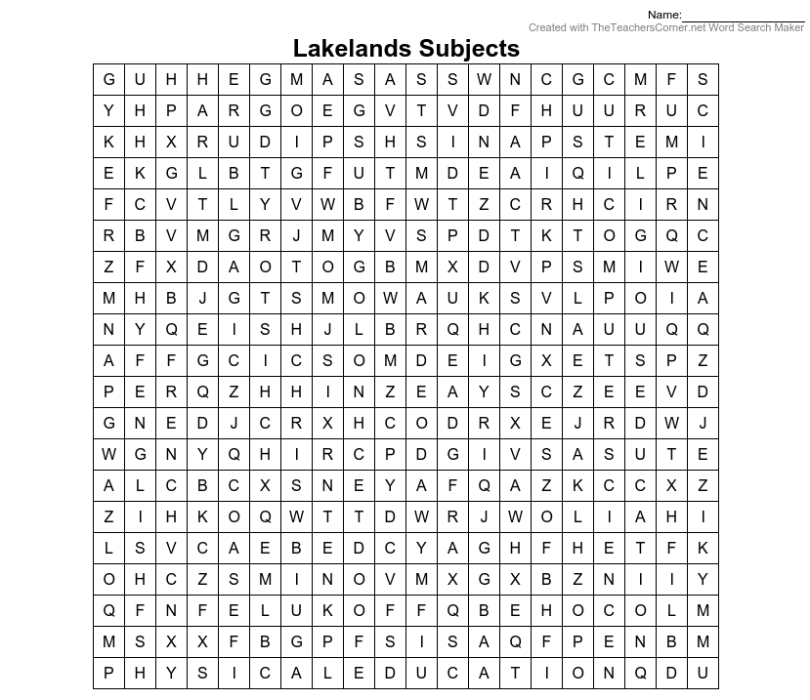
Find the 17 subjects that you will be taught at Lakelands Academy in the word search. Write them down in the space below.

